## **Week 4 Homework: Linux Systems Administration**

### **Scenario**

In the previous class activities, you acted as system administrator in order to troubleshoot a malfunctioning server.

The senior administrator was quite pleased with your work. Now, they would like you to prepare another server to replace this server. You are tasked with completing the steps below to prepare a new server.

### **Lab Environment**

Log into your local virtual machine. Use the following credentials:

* Username: sysadmin
* Password: cybersecurity

In order to get started with your tasks, you will need to open the Terminal within your Ubuntu VM. If you are unsure how to do it, within your Ubuntu VM, do the following:

* Open the Linux terminal by pressing Ctrl+Alt+T for Windows users or Ctrl+Options+T for Mac users.
* Alternatively, press Windows+A or Command+A for Mac users, then type "Terminal" in the search bar and select the Terminal icon (not the Xfce Terminal icon).

### **Instructions**

As you solve each step below, please fill out the Submission File. This will be your homework deliverable.

For each of the following steps, you will need to run the correct command and confirm the results.

#### **Step 1: Ensure Permissions on Sensitive Files**

The /etc/ directory is where system configuration files exist. Start by navigating to this directory with cd /etc/.

Inspect the file permissions of each of the files below. This should have already been completed in the activity, but let's double check! If they do not match the descriptions, please update the permissions.

1. Permissions on /etc/shadow should allow only root read and write access.
   1. sudo chown -R root /etc/shadow
   2. sudo - superuser permissions
   3. chown - change owner
   4. -R = operate on files and directories recursively
2. Permissions on /etc/gshadow should allow only root read and write access.
   1. sudo chown -R root /etc/gshadow
   2. sudo - superuser permissions
   3. chown - change owner permissions
   4. -R = operate on files and directories recursively
3. Permissions on /etc/group should allow root read and write access, and allow everyone else read access only.
   1. sudo chmod 644 /etc/group  
      Picture shows above commands

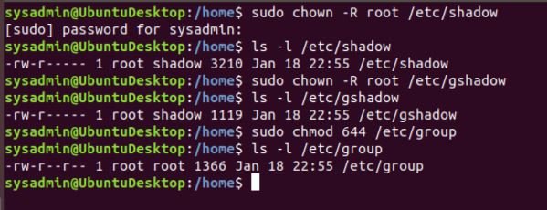

1. Permissions on /etc/passwd should allow root read and write access, and allow everyone else read access only.

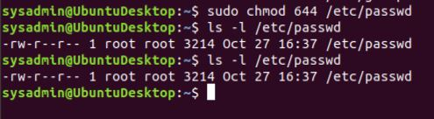

* **Hints:**
  + Run the following command to view the file permissions: ls -l <file>
  + If permissions need to be changed or modified, use the chmod command.

#### **Step 2: Create User Accounts**

This step asks you to set up various users. These commands do not require you to be working from a specific directory.

1. Add user accounts for sam, joe, amy, sara, and admin.  
   * **Hint:** In order for users to be added to the system, you need to run the command with sudo.

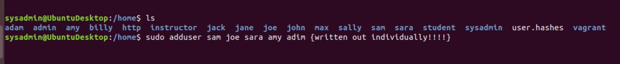

1. We want to make sure that only the admin user has general sudo group access. This requires a command that will allow user modifications.
   * sudo usermod -aG sudo admin
   * Superuser permissions to modify a user
   * -aG = append (Groups) [add the user to the supplementary group(s)]
   * sudo = group to add the user to
   * admin = user



#### **Step 3: Create User Group and Collaborative Folder**

Now we want to execute the commands to fully set up a group on our system.

This requires us to create a group, add users to it, create a shared group folder, set the group folder owners for these shared folders.

1. Add the group engineers to the system.  
   
2. Add users sam, joe, amy, and sara to the managed group. This will be similar to how you added admin to the sudo group in the previous exercise.  
   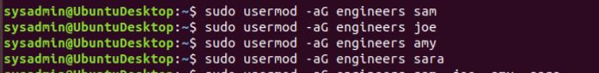
3. Create a shared folder for this group: /home/engineers.  
   
4. Change ownership on the new engineers' shared folder to the engineers group.

#### **Step 4: Lynis Auditing**

The final step on your administrator's list involves running an audit against the system in order to harden it. You'll use the system and security auditing tool Lynis to do so.

1. Install the Lynis package to your system if it is not already installed.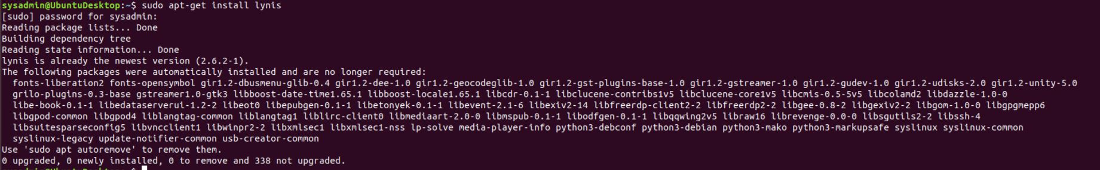
2. Check the Lynis documentation for instructions on how to run a system audit.
   1. sudo lynis help ---> sudo lynis audit system
3. Run a Lynis system audit with sudo.  
   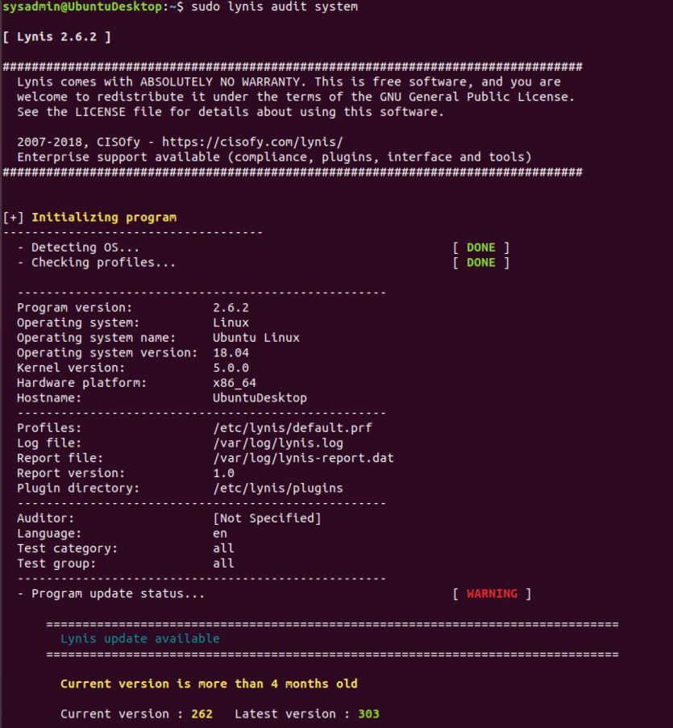
4. Provide a report from the Lynis output on what more could be done to harden the system.
   1. We could add a malware scanner,

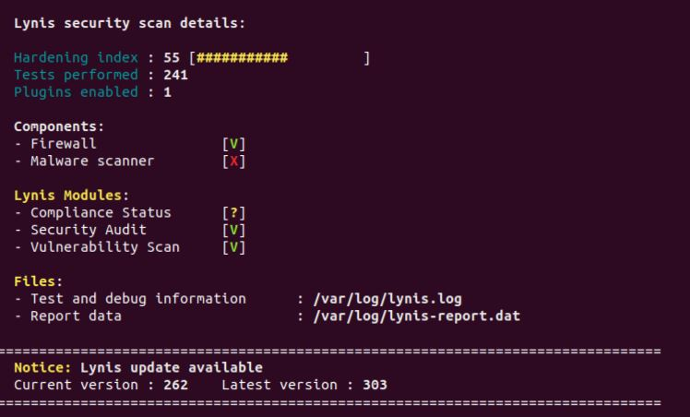

#### 

#### 

#### 

#### **SEE BONUS BELOW! :)**

#### 

#### 

#### 

#### 

#### 

#### 

#### **Bonus**

Despite claims from enthusiasts, Linux is *not* immune to malware. You will need to install and run the application chkrootkit, to search for any potential rootkits installed on the system.

1. Install the chkrootkit package to your system if it is not already installed.
   1. sudo apt-get install chkrootkit
   2. apt-get = APT package handling utility (get) install the package “chkrootkit”  
      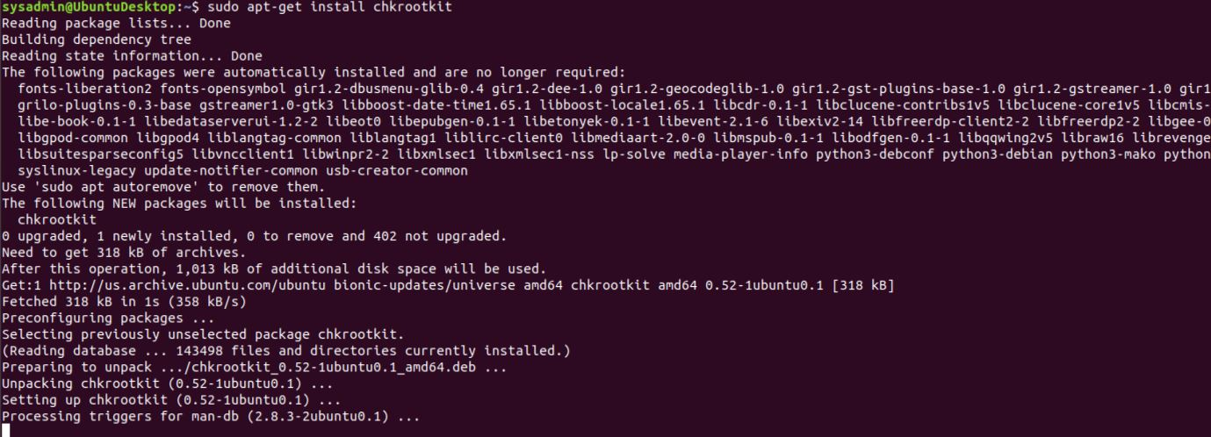
2. Check the chkrootkit documentation for instructions on how to run a scan to find system root kits.q
   1. Just run it as ‘sudo chkrootkit’
3. Run chkrootkit (with sudo) in expert mode to verify the system does not have a root kit installed.
   1. sudo chkrootkit -x
   2. 
4. Provide a report from chkrootkit output on what more could be done to harden the system.

